**NOSC-CSDB ONE DRIVE SETUP GUIDE**

## Reference(s):

1. None

## Overview:

This is intended to assist end users

## Purpose:

The purpose of this guide is to assist Coast Guard personnel with getting setup with One Drive on approved Coast Guard workstations and Laptops

**The key factor** to consider is whether or not you have been **migrated to M365** or not. One Drive is only available to those that have been migrated to M365

## Procedures:

* Go to <HTTPS://WEBMAIL.APPS.MIL> in Internet Explorer or Google Chrome
* It should redirect you to a login page.
* Please type your coast guard email address in here

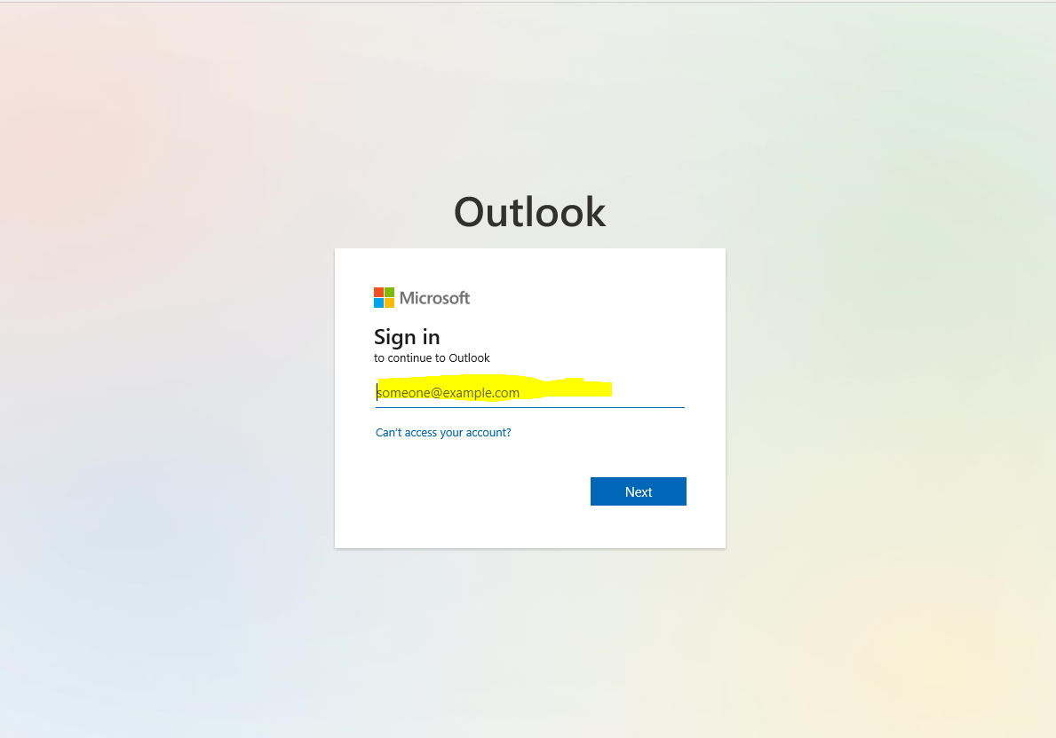

* It should now display your coast guard email inbox
* In the TOP LEFT CORNER select the 6 dot button



* Select ONEDRIVE From the menu
* Up Top Select SYNC



* A wizard will pop up walking you through a few steps to setup a ONEDRIVE Folder on your local machine
* After ONEDRIVE Wizard is computer and you have went through all the steps it should direct you to your new ONEDRIVE Folder on your computer
* Right Click on OneDrive – United States Coast Guard folder
* Select Always Keep On this Device

You are finished

* Anything you keep in this folder will auto sync into your one drive eliminating the grey x issue and allowing ease of access for your files